**CHAPTER-1**

# INTRODUCTION

**Abstract:** ***Recent technology developments permit multi-site, web-based data entry system, as well as the storage of data in a single location. As a consequence, investigator may access data instantly, participant burden and human entry error are decreased, and the integrity of clinical trial data is enhanced. This paper’s goal is to outline the creation of a thorough, web-based data management system for a multi-site randomised behavioural intervention experiment. Interdisciplinary cooperation, design mapping, feasibility analyses, and feedback from an advisory board of past patients with trials comparable to the targeted group were among the strategies utilised to develop this study-specific data management system. For additional behavioural intervention research, the resulting data management system and development methodologies serve as a model***

***Many organisations particularly education institutions, have established information retrieval systems employing web-based applications. The goal of E-Gazette Data-base system is to develop efficient research tools for researchers to access, examine, and utilise the material, perhaps enhancing the productivity and calibre of their work. Using PHP, MySQL, and Apache, E-Gazette Data-Base was developed for the National Informatics Centre Department of the Faculty of National Informatics Centre.***

## 1.1 INTRODUCTION

Online E-Gazette system projects main idea is to implement a web-site that store the gazette data in the web-site. It has feature of creating the gazette rule, updating the gazette rule, removing the gazette rule, and deleting the gazette rule. There will be an admin login which has permission to update, delete or creating the database of the gazette and it will change on the user view side. There is a table page which contain the gazette section and article of the gazette. This web-site will at least solve some of the problem cause in the publishing of new gazette.

### 1.2 PROBLEM STATEMENT

Gazette is publishing on weekly, monthly or year so it is in the form of typing in the paper after the it scans the paper and convert into the pdf form and publish it on the government website of gazette. So, updating, deleting, creating rule is such a problem and it is unreliable we need to type the same gazette again and publish again with one change.

#### 1.3 OBJECTIVE

Online E-Gazette system is a Web project built in Web Application. Just a simple application with minimalistic design and user-friendly functionality, that’s it. This E-Gazette has stored the data of gazette on website and it has the feature like updating, creating, and deleting. Instated of typing the same gazette and change some section or article we can just go through this website and just login to the admin section and perform the updating or changing or adding the section or articles.

# CHAPTER-2

**SYSTEM REQUIREMENTS SPECIFICATION**

A System Requirements Specification is a document or set of documentation that describes the features and behaviour of a system or software application. It includes a variety of elements that attempts to define the intended functionality required by the customer to satisfy their different users.

## 2.1 HARDWARE REQUIREMENTS

* 400 MB hard disk space.
* 4 GB RAM.
* High speed Network Connectivity.

## 2.2 SOFTWARE REQUIREMENTS

* Windows(x64) Operating System.
* Vs code
* Xamp

## 2.3 LANGUAGES USED

The languages used are as follows:

* **Hyper Text Markup Language** (**HTML**) it is to design web pages using a markup language. HTML is the combination of Hypertext and Markup language. Hypertext defines the link between web pages. A markup language is used to define the text document within the tag which defines the structure of web pages.
* **Cascading Style Sheets (CSS)** is a style sheet language used for describing the presentation of a document written in a markup language such as HTM or XML. CSS is designed to enable the separation of presentation and content, including layout, colours, and fonts.
* **JavaScript**  is a high-level, often just-in-time compiled language that conforms to the ECMAScript standard. It has dynamic typing, prototype-based object-orientation, and first-class functions. It is multi-paradigm, supporting event-driven, functional, and imperative programming styles. It has application programming interfaces (APIs) for working with text, dates, regular expressions, standard data structures, and the Document Object Model (DOM).
* **Php** code is usually processed on a web server by a PHP interpreter implemented as a module, a daemon or as a Common Gateway Interface (CGI) executable. On a web server, the result of the interpreted and executed PHP code – which may be any type of data, such as generated HTML or binary image data – would form the whole or part of an HTTP response. Various web template systems, web content management systems, and web frameworks exist which can be employed to orchestrate or facilitate the generation of that response. Additionally, PHP can be used for many programming tasks outside the web context, such as standalone graphical applications and robotic drone control. PHP code can also be directly executed from the command line.
* **MySQL** is an open-source relational database management system (RDBMS). Its name is a combination of "My", the name of co-founder Michael Widenius's daughter My, and "SQL", the abbreviation for Structured Query Language. A relational database organizes data into one or more data tables in which data may be related to each other; these relations help structure the data. SQL is a language programmers use to create, modify and extract data from the relational database, as well as control user access to the database. In addition to relational databases and SQL, an RDBMS like MySQL works with an operating system to implement a relational database in a computer's storage system, manages users, allows for network access and facilitates testing database integrity and creation of backups.

`

**CHAPTER-3**

**SYSTEM DESIGN AND IMPLIMENTATION**

**SYSTEM DESIGN**

Systems design is the process of defining the [architecture](https://en.wikipedia.org/wiki/Systems_architecture)[, product design,](https://en.wikipedia.org/wiki/Product_design) modules, interfaces, and [data f](https://en.wikipedia.org/wiki/Data)or a [system t](https://en.wikipedia.org/wiki/System)o satisfy specified [requirements.](https://en.wikipedia.org/wiki/Requirement) Systems design could be seen as the application of [systems theory t](https://en.wikipedia.org/wiki/Systems_theory)o [product development. T](https://en.wikipedia.org/wiki/Product_development)here is some overlap with the disciplines of [systems analysis,](https://en.wikipedia.org/wiki/Systems_analysis) [systems architecture a](https://en.wikipedia.org/wiki/Systems_architecture)nd [systems engineering](https://en.wikipedia.org/wiki/Systems_engineering)

**3.1 FLOW DIAGRAM:**

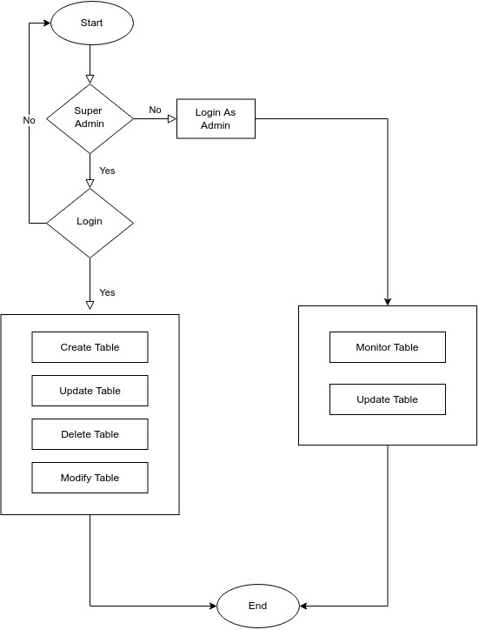

**FIG 3.1 Flow Diagram**

The flow diagram for E-Gazette system is as shown in fig 3.1. It starts with the admin i.e., admin has a permission to change and edit first we need to login as admin and can use those operation and user can only use the view permission.

## 3.2 USE CASE DIAGRAM

**-**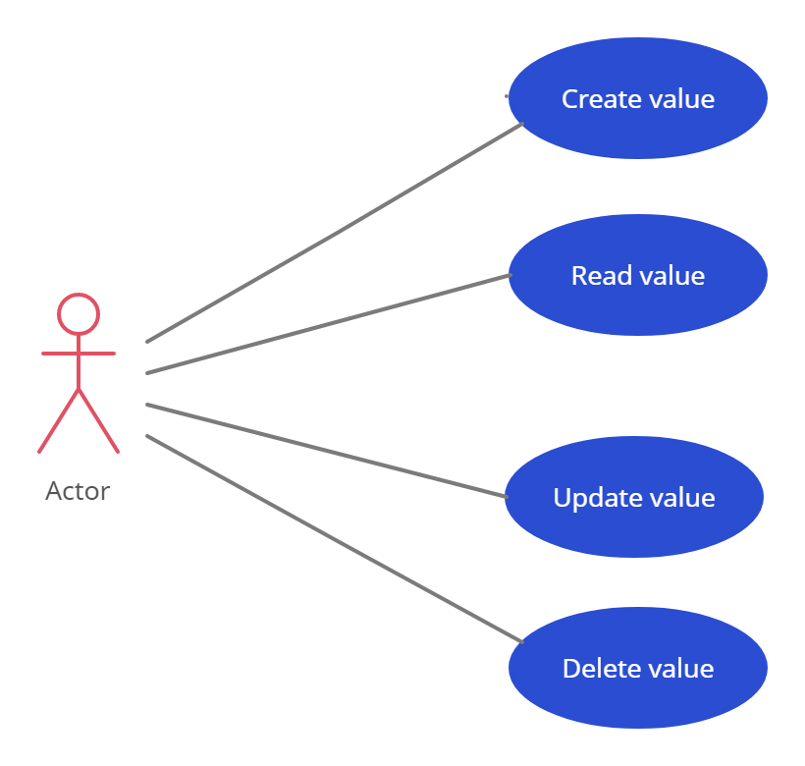

**FIG 3.3: Use Case Diagram**

The online E-Gazette website use case diagram is as shown in fig 3.2. This E-Gazette use case diagram can help us: - Summarize the details of your system’s users (also known as actors). - Organize a Gazette interactions. - Access the UML shape libraries. Open this template to view a detailed example of a gazette use case diagram that you can customize to your use case.

# CHAPTER-4

**RESULTS**

This chapter contains the screenshots of the results like the main page and currency exchange rates.

## 4.1: SNAPSHOTS

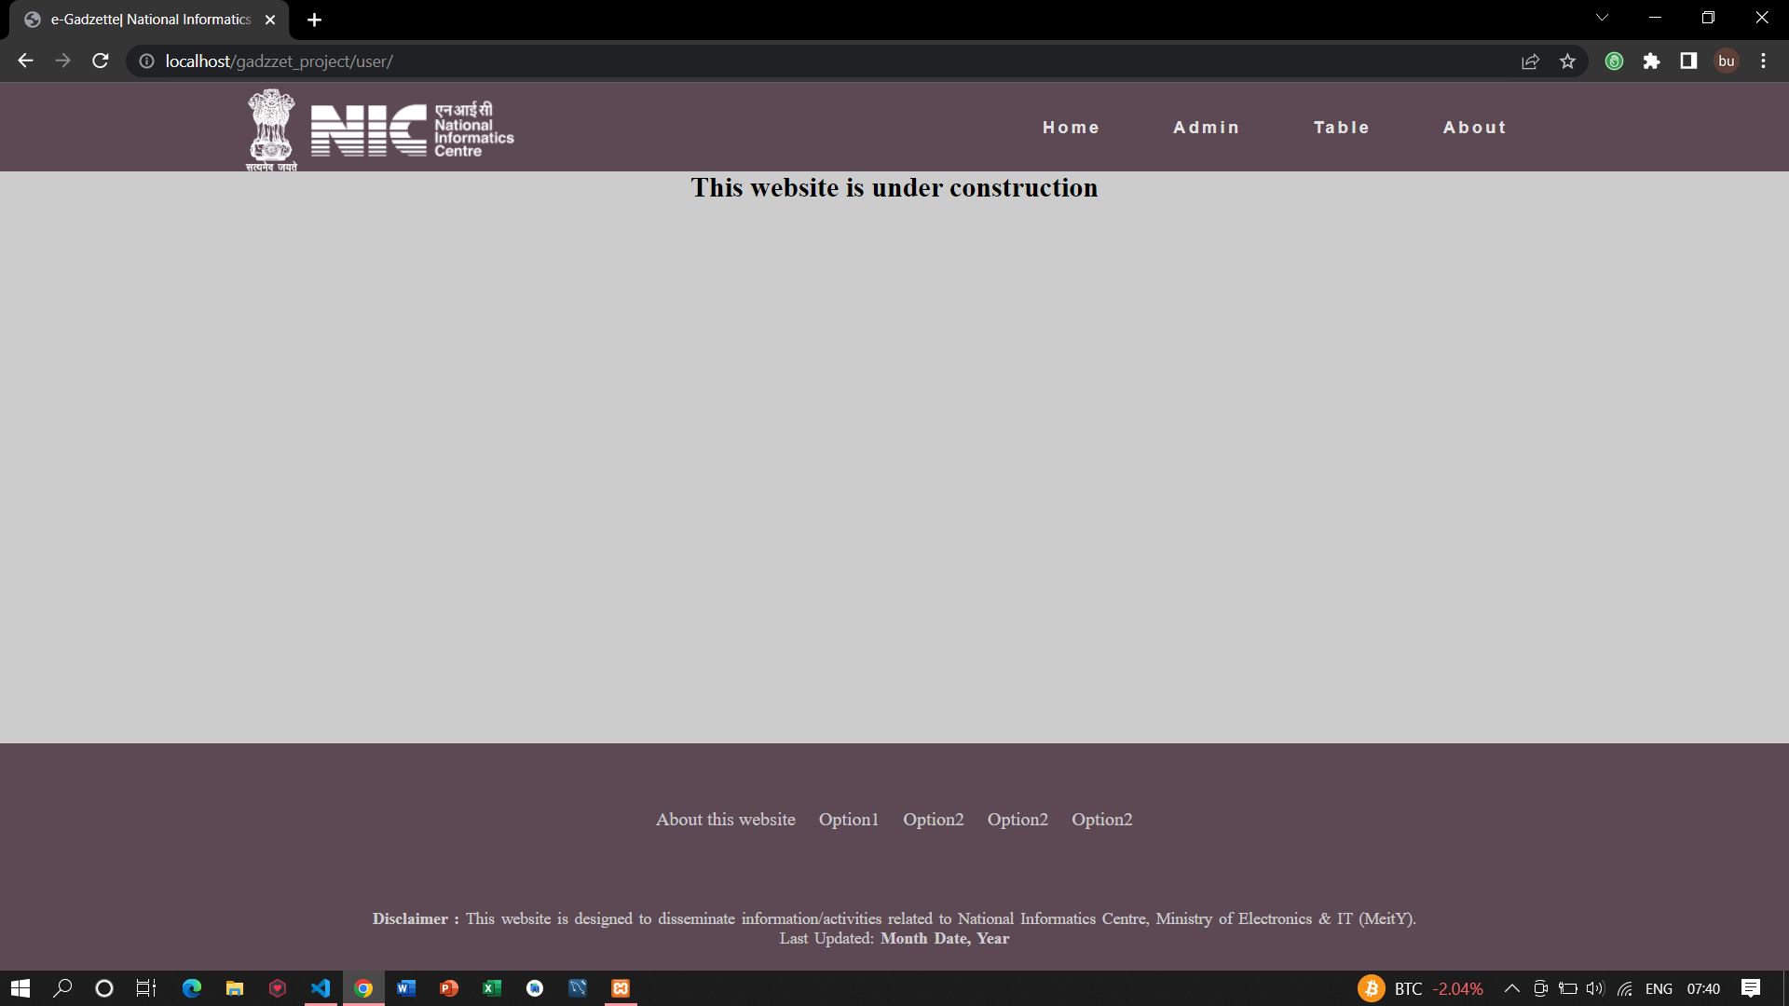

Fig1.1. Main page

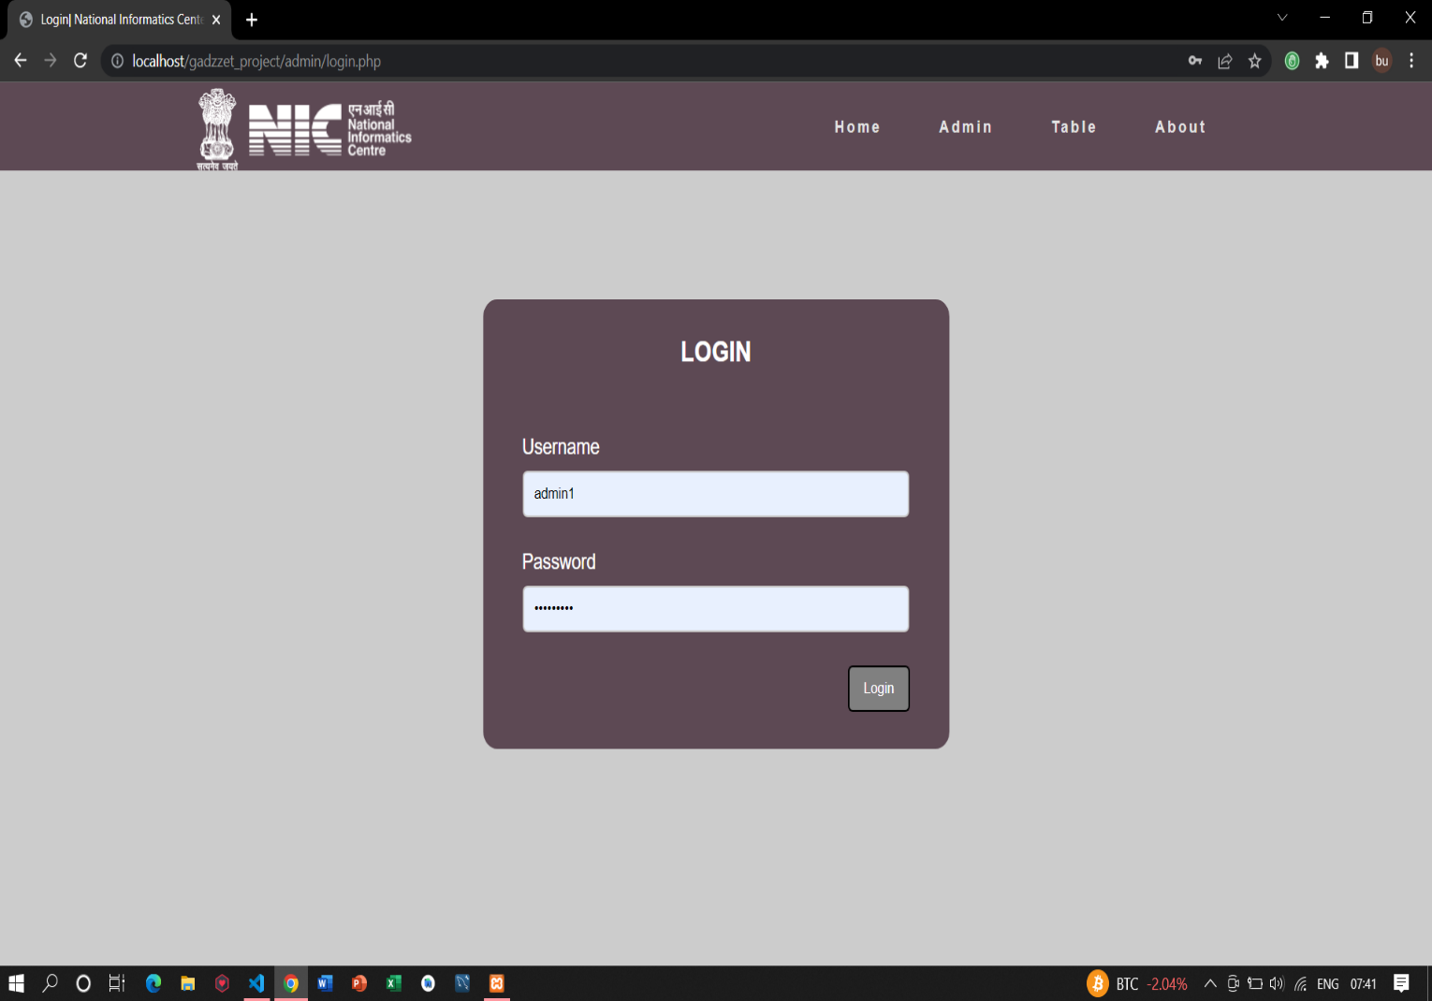

Fig1.2. Login Page

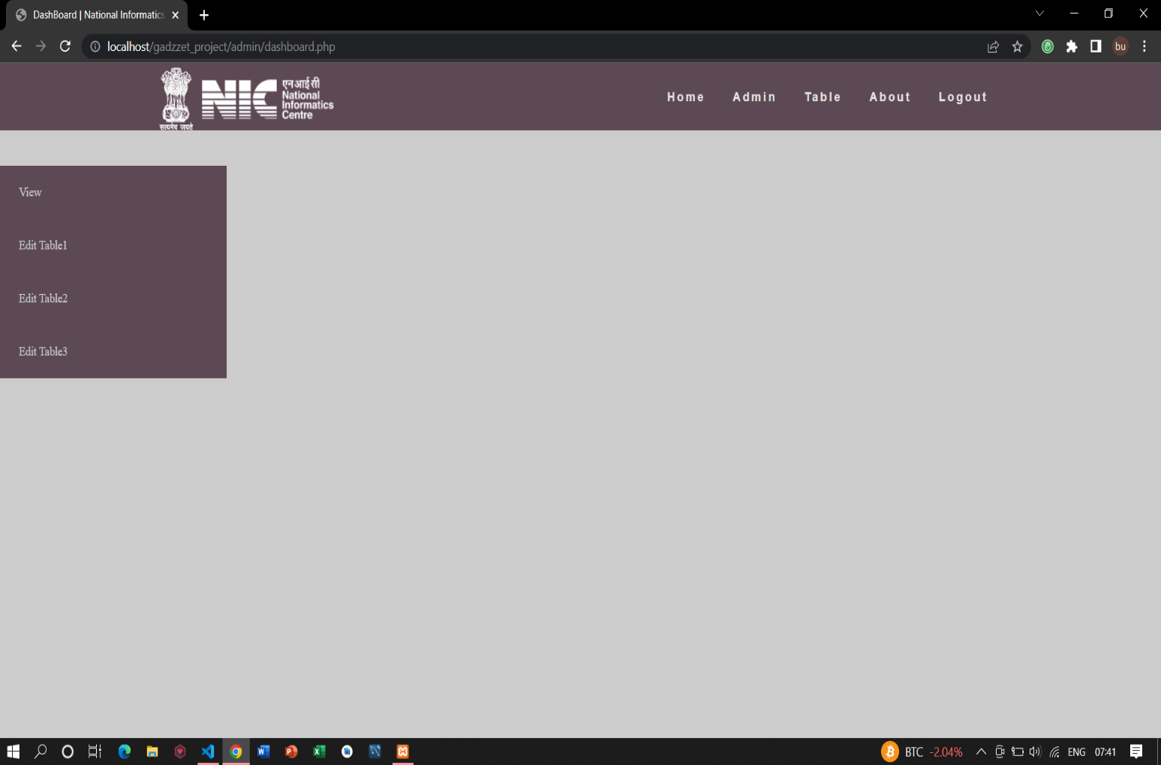

Fig1.3. Admin dashboard

#### 4.2 DRAWBACK

None of the thing in this world doesn’t have disadvantage. There are few disadvantages there while using online data storage but if you handle things with care then you can surely avoid them. Some of them are as follows-

Improper handing can cause trouble: You must need your user-id and password safe to protect your data as if someone knows or even guess your credentials, it may result in loss of data. Use complex passwords and try to avoid storage them in your personal storage devices such as pen drive and HDD.

Choose trustworthy source to avoid any hazard: There are many online storage sites out there but you have to choose the one, on which you can trust. You can always refer the list of free online data storage sites, which I shared above Internet connection sucks!! To access your files everywhere the only thing you need is internet connection. If you don’t get internet connection somewhere then you will end up with no access of data even though it is safely stored online.

## CONCLUSION

The main purpose of this website is in order to save time and reduce the problem occur on publishing or update a gazette and the reader how read and research on it to save time and reliable to me to research easy without occurring any problem. By this website the problem cause in publishing Gazette or researching in Gazette have at least solve through this website by saving time consumption and reduce the old problem in publishing the gazette and so no.